Stacey Coolwell Consultancy
whISPers Women’s
Wellbeing Workshop

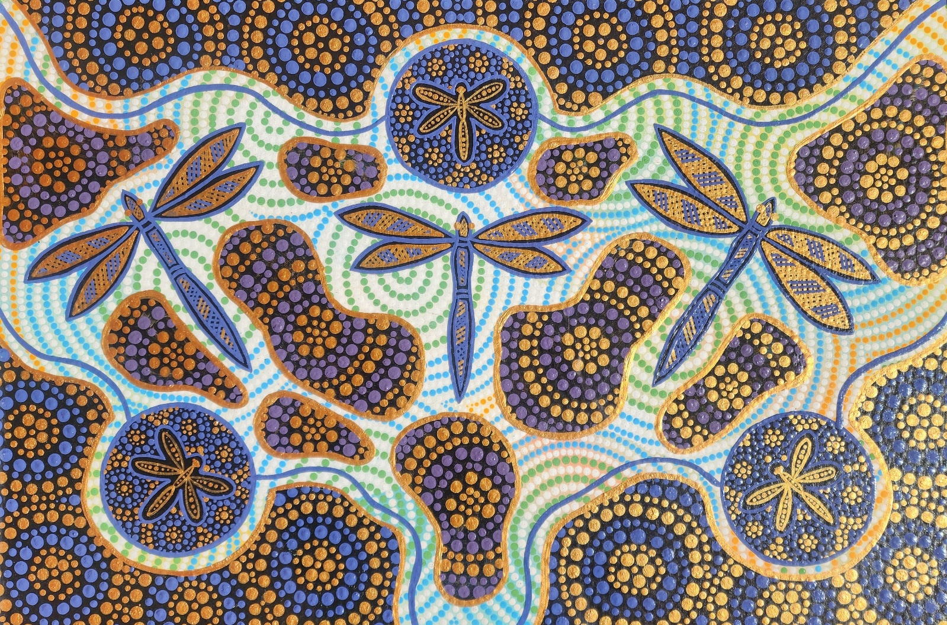
Designed by Hal Oram

whISPers Women's Wellbeing Workshop is to provide a safe and culturally sensitive space for women to explore, reflect, and grow in their social and emotional wellbeing.

Program
The whISPers Aboriginal and Torres Strait Islander Women's Wellbeing workshop is a comprehensive program. Throughout the workshop, there are opportunities for open discussions, sharing personal stories, and learning from each other's experiences.
Outline of the program:
1. Social and Emotional Wellbeing: The workshop begins by exploring the concept of social and emotional wellbeing and its importance in the lives of Aboriginal and Torres Strait Islander women. Participants learn about the different dimensions of wellbeing and how they can nurture their mental, emotional, and social health.
2. Social and Emotional Wellbeing Self-Care Model: This session introduces a self-care model specifically tailored for Aboriginal and Torres Strait Islander women. Participants learn about practical strategies and techniques to prioritise self-care and enhance their overall wellbeing in their daily lives.
3. Cultural Reflection about Yourself: This session encourages participants to reflect on their cultural identity and the role it plays in their overall wellbeing. Through guided discussions and activities, women delve into their personal connection to culture, heritage, and community.
4. Individual Values: Participants explore their individual values and beliefs that guide their actions and decisions. This session helps women identify their core values and understand how they can align their lives with these values to enhance their wellbeing.
5. My Strengths and Qualities: In this session, participants identify and celebrate their strengths and positive qualities. Through self-reflection and group activities, women gain a deeper understanding of their unique abilities and learn how to leverage them for personal growth and resilience.
6. Tree of Life: The Tree of Life activity is a powerful metaphorical exercise that helps participants explore their life journey and the different aspects that contribute to their wellbeing. Women create their own symbolic tree, branches representing different areas of their life, and reflect on their strengths, hopes, and dreams.
7. Cultural Wheel of Life Activity: The Cultural Wheel of Life activity helps participants assess and enhance their overall cultural wellbeing. Women explore different dimensions of culture, such as language, spirituality, family, community, and traditional practices, and identify areas where they can further connect and engage.

Social and Emotional Wellbeing
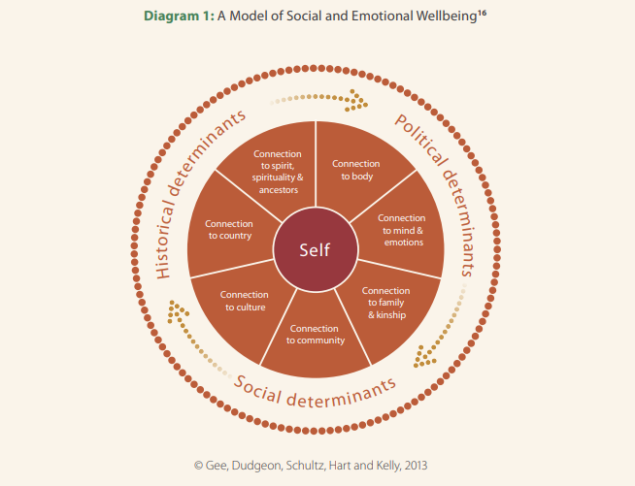

The Model of Social and Emotional Wellbeing proposed for Aboriginal and Torres Strait Islander Peoples encompasses seven interconnected domains. These domains recognise the holistic nature of health and wellbeing, influenced by various factors. Here they are:
Body: This domain relates to physical health and wellbeing.
Mind and Emotions: It encompasses mental health, cognitive wellbeing, and emotional balance.
Family and Kin: Focusing on relationships within families and extended kinship networks.
Community: Recognising the importance of social connections, belonging, and community support.
Culture: Embracing cultural identity, traditions, and practices.
Country: Refers to the connection to land, sea, and environment.
Spirituality and Ancestors: Acknowledging spiritual beliefs, connection to ancestors, and cultural practices

National Strategic Framework for Aboriginal and Torres Strait Islander Peoples’ Mental Health and Social and Emotional Wellbeing 2017-2023

Social and Emotional Wellbeing Self-Care Model
Self-care is any activity that we do to take care of our mental, emotional, and physical health. Although it's a simple concept in theory, it's something we very often overlook. Good self-care is key to improved mood and reduced anxiety.
Below is one concept of Social and Emotional Wellbeing Self-Care, think of how a car needs care for it to function.

FUEL/Psychical
- Diet
- Exercise
- Sleep
- Relaxation

OIL/Emotional
- Doing things, you enjoy
- Me Time
- Being with people who support you

WATER/Spiritual
- Things that give us meaning and purpose
- People
- Places
- Animals
- Plants
- Universe
- Culture

Cultural Reflection About Yourself
These activities will help you, build on your cultural identity that holds significant meaning to you?
In the circle create an artwork/or write anything

Where was I born?

My country/people?

Where did I grow up as child?

What places are special to me?

My language groups?

My cultural totem?

Write a list of cultural ways my culture makes me strong? E.g. being on country, family, supports, my friends, mob or elders. This can also be a personal list not necessarily a cultural list.
______________________________ ____________________________

______________________________ _____________________________
______________________________ _____________________________
______________________________ _____________________________
______________________________ _____________________________
______________________________ _____________________________
______________________________ _____________________________

Individual Values
Your values are the beliefs that define what is most important to you. They guide each of your choices in life. For example, someone who values family might try to spend extra time at home, while someone who values success in their career may do just the opposite.

Understanding your values will help you recognise areas of your life need more attention, and what to prioritise in the future.

Select the 10 most important items form the following list. Rank them from 1-10 with “1” being the most important item.

___ Love ___ Honesty
___ Wealth ___ Humour
___ Family ___ Loyalty
___ Morals ___ Reason
___ Culture ___ Independence
___ Knowledge ___ Achievement
___ Power ___ Beauty
___ Friends ___ Spirituality
___ Free Time ___ Respect
___ Adventure ___ Peace
___ Variety ___ Stability
___ Calmness ___ Wisdom
___ Freedom ___ Fairness
___ Fun ___ Creativity
___ Recognition ___ Relaxation
___ Nature ___ Safety
___ Popularity ___ Success
___ Responsibility ___ __________

My Strengths and Qualities
Things I am good at: Compliments I have received:
- ____________________________ 1. ___________________________
- ____________________________ 2. ___________________________
- ____________________________ 3. ___________________________

What I like about myself: Challenges I have overcome:
1. ____________________________ 1. ___________________________
- ____________________________ 2. ___________________________
- ____________________________ 3. ___________________________
In the square below create an artwork/or write something that is my safe place.

How have I helped other people by: Things that make me unique:
1. ____________________________ 1. ___________________________
2. ____________________________ 2. ___________________________ 3. ____________________________ 3. ___________________________
What I value the most: Times I’ve made others happy:
1. ____________________________ 1. ___________________________
2. ____________________________ 2. ___________________________
3. ____________________________ 3. ___________________________

Tree of Life Concept
The tree of life concept is simple and straight forward. It is a visual metaphor in which a tree presents your life and the various elements that make up you’re: Past, Present and Future. Below is an example of what the tree of life exercise will look like once completed.
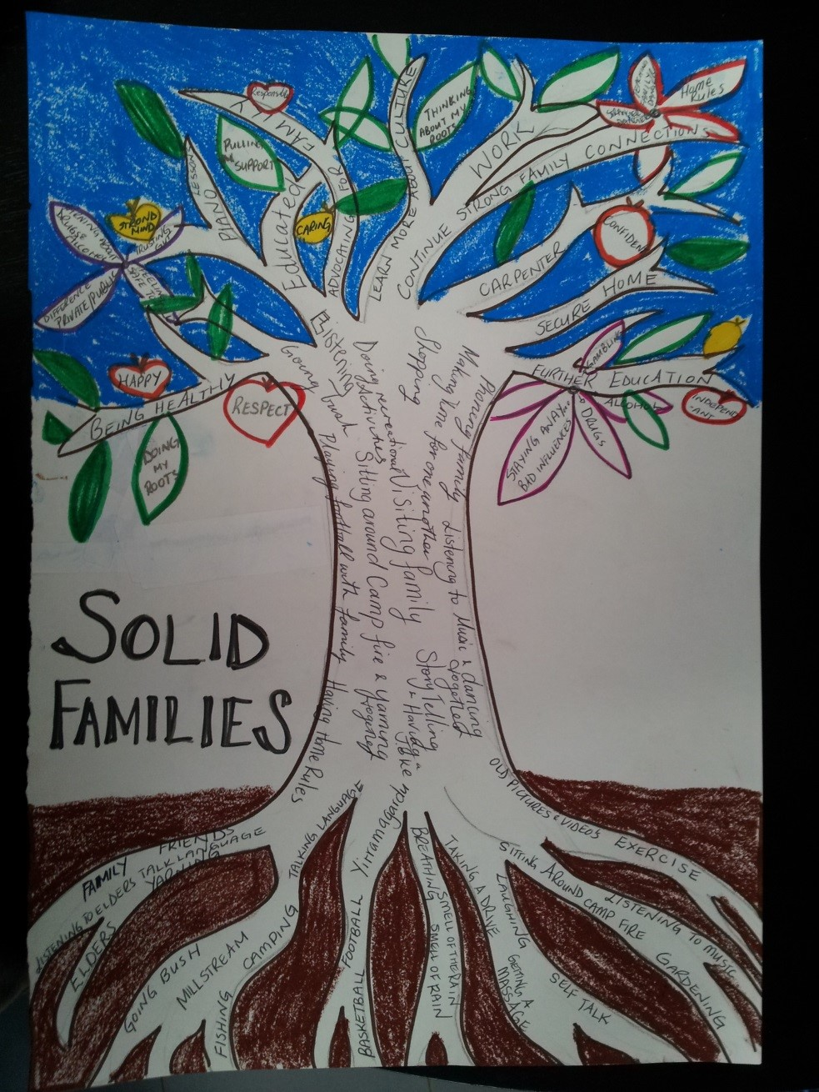

The Tree of Life Exercise
Read the instructions below, how you can create your own tree on the next page.
The Roots
Write down the things you choose to do on a weekly basis on the ground. These should not be things you are forced to do, but rather things you have chosen to do for yourself.
The Trunk
Write your skills and values on the trunk, write your values starting at the base of the trunk going up, this will be a natural progression from the ground, roots, to your values.
The Branches
Write down your hopes, dreams and wishes on the branch. These can be personal, communal, or general to all mankind. Think both long and short term. Spread them around the various branches.
The Leaves
Write down the legacies that have been passed on to you. Think about the impact they’ve had on you and what they’ve given to you over the years. Most often this will be attributes such as culture, courage, generosity, kindness, strength etc.
The Flowers & Seeds (Create/draw these objects in your tree)
Write down the legacies you wish to leave others on the flowers and seeds.

Social, Emotional and Wellbeing Wheel of Life
All about you, your life, what your day-to-day life contains, balancing your world with your ambitions, fears, issues or problems. The eight spokes of the wheel represent different aspects of your life.
This exercise will help you identify where you can change what you do to realign where you are going – so that you give yourself a more balanced and healthier lifestyle.
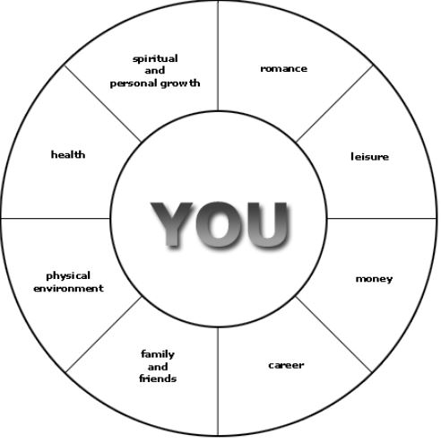
See diagram below as an example.

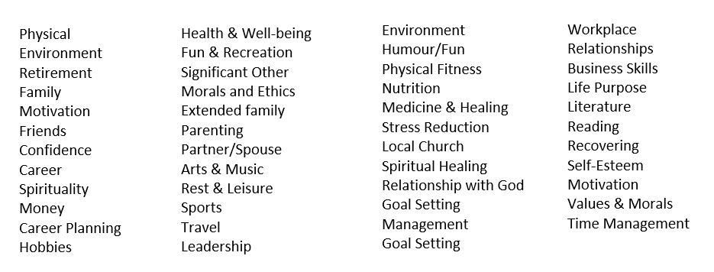

Exercise
- Complete your diagram below by writing which aspects are the most important to you from the eight topics in diagram below.
- When you have decided to give yourself a rating out 100%, then also rate how you feel today and your desire to work to your rating.
- Now think for a few moments about your life, asking yourself some simple questions.
  - What do I truly want from life?
  - What am I not paying attention to in my life right now?
  - What am I not honouring as much as I could?
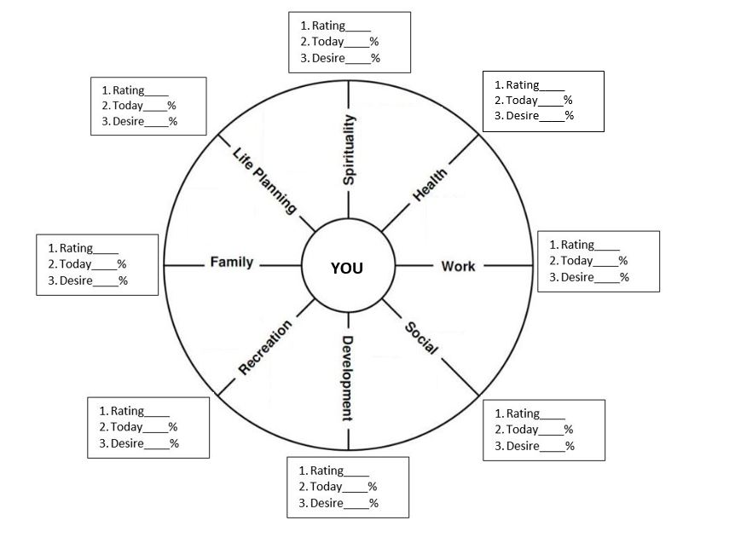
  - What is the easiest step I can take right now, today, or this week in the direction of what I want?

Make an agreement with yourself to review your personal balance from time to time, whether there is any feedback that suggests you need adjust or realign your goals. Perhaps you might do it every month, or six months or each year on an anniversary. Making regular reviews of how things are is part of forming the good habit of regularly checking in with yourself.

